20150207 Automation Technology Club Features - Club Videos/Google Plus

**Automation Technology Club Videos:**

[Automation Technology Club Video Feb 19, 2015](https://www.youtube.com/watch?feature=player_embedded&v=CqDEZYoIr2U) THIS WEEK

[Automation Technology Club Video Feb 12, 2015](https://www.youtube.com/watch?v=IF96WUUG26g)

The link to the "Automation Technology Club" community is:

<https://plus.google.com/communities/101659244920289753698>

**This document shows you how to visit with us at the *Automation Technology Club* or see the Video (if one is produced this week).**

As Usual: Poo Bah wants to know how to get there. Poo is always lost. His most noteworthy quote “Where am I?”. So how do you get Poo to google plus????

GETTING TO GOOGLE PLUS

1. Start the google plus application by:
2. Press the google applications button  in Gmail or Google search
3. select google plus 
4. Select the “All” tab (insures even Poo does not get lost).
5. You are now in Google Plus.
6. Select the “Automation Technology” Community by clicking  and typing “automation technology” in the search box. Then select the “Automation Technology Club” from the list.

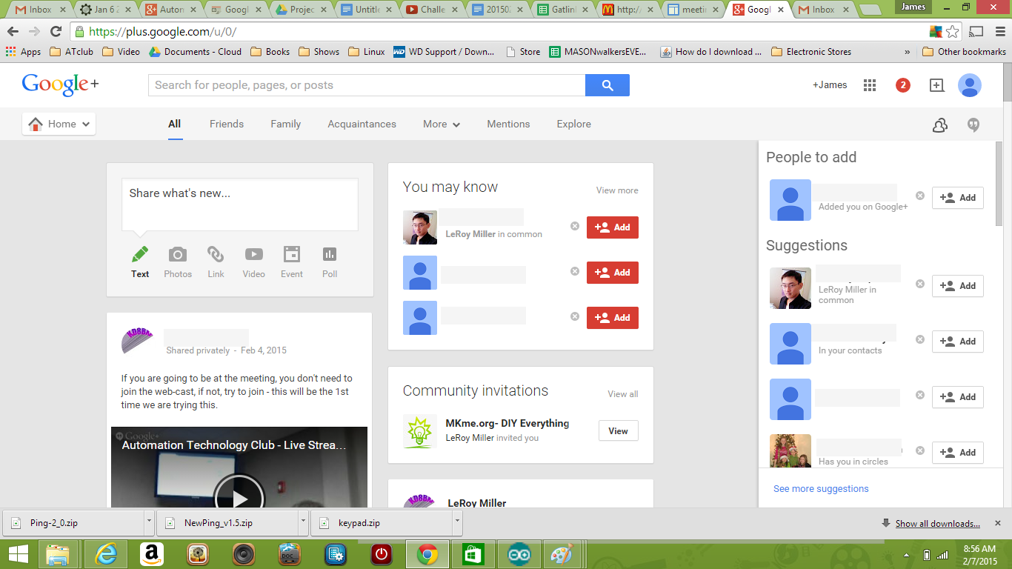

2. So what is “All” this.

1. Most interesting to the Poo Bah is the CLUB MEETING VIDEO at the bottom left.

This particular video was an early creation of the club ProjectMonster/Movie Producer.introducing the illustrious Grand Poo Bah (who later graps the camera and runs around like a wild man (regular members have long since reconciled themselves to this foolishment). The POOB is ready to jump ship. The customer hook has been established (Members can watch video, projectMonster has people looking at “Google Plus”. The world is a happy place. Proceed at your own risk.

b.The top left reveals “Share What’s New”:

It looks like you have to opportunity to share things with someone.

Looks like POOB is creating at text about himself (what else is new).

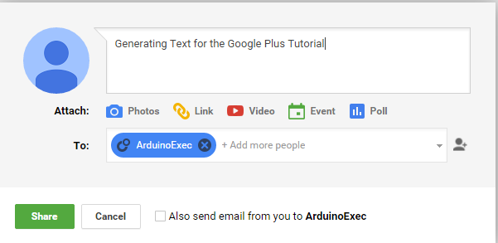”

It looks like text messages automatically go to the ArduinoExec “Circle”? I am guessing the two circles indicate “AutoExec” is a circle (POOB recognizes this as a Gmail group). It looks like you can add additional Circles, Gmail addresses, Families etc to the list. Not Bad!